DBMS Lab Assignment 2B

Neeti Kurulkar

Write at least 10 SQL queries on the suitable database application using SQL DML statements

Queries:

1. Create a table EMP.

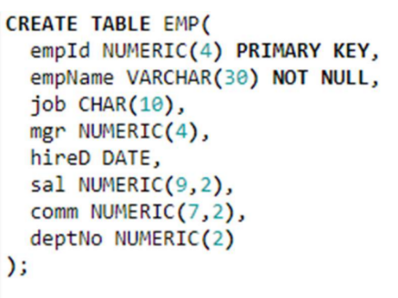

1. Create a table DEPT.

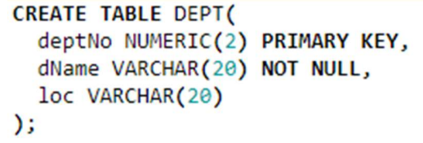

1. Insert records into EMP table.

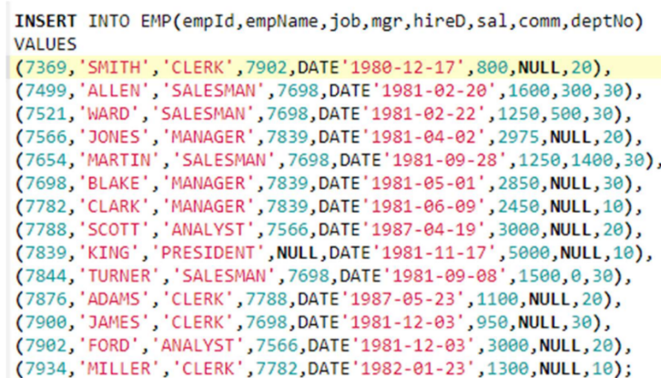

1. Insert records into DEPT table.

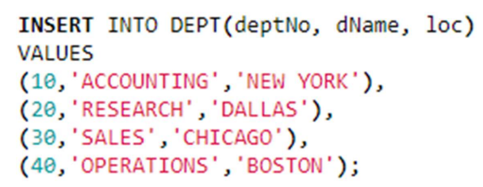

1. Select all records from EMP table.

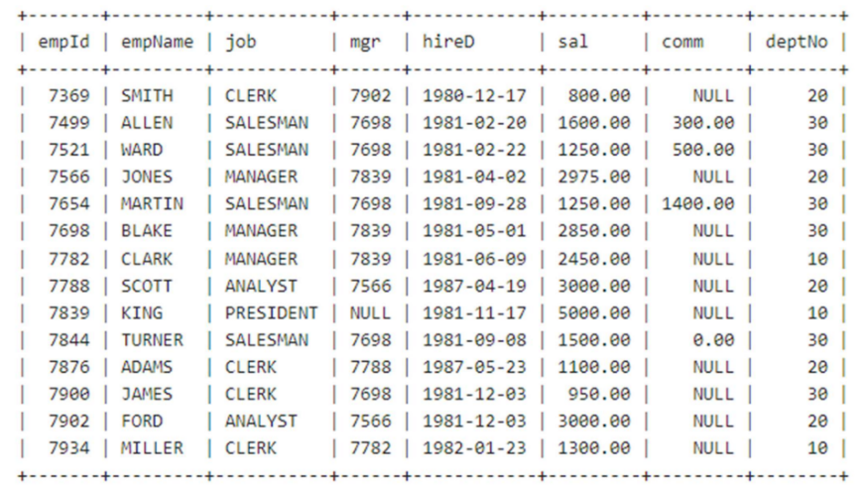

1. Select all records from DEPT table.

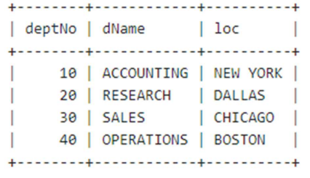

1. Find the employee’s name, salary who is working in department number 20.

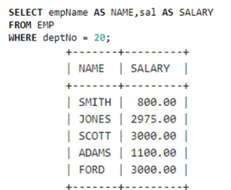

1. Find employee’s name, job, salary of the employee who is ‘Manager’.

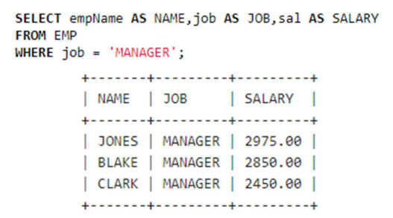

1. Find employee’s name, job, salary of the employee who isn’t a ‘Manager’.

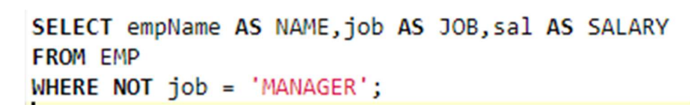

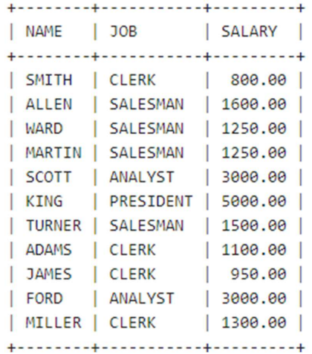

1. Find employees who were hired between 1 MAR 1981 and 1 JUN 1983.

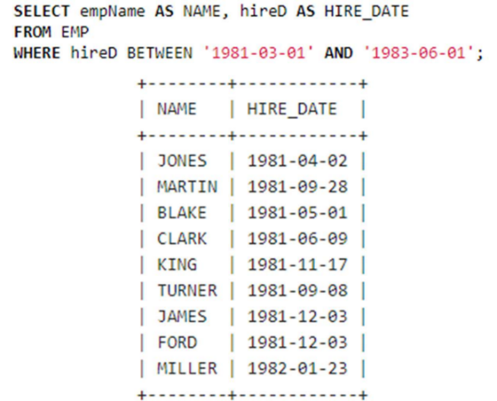

1. Find Employees hired in 1981. 12. Find employees whose name starts with ‘S’.

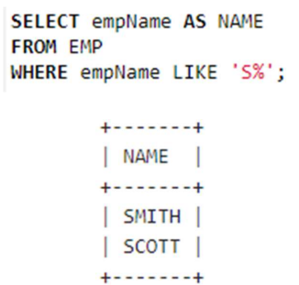

1. Find employees whose name ends with ‘S’.

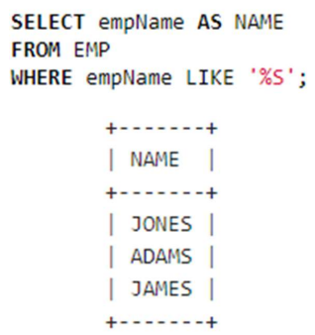

1. Find employees working in Department Number 20 and 40.

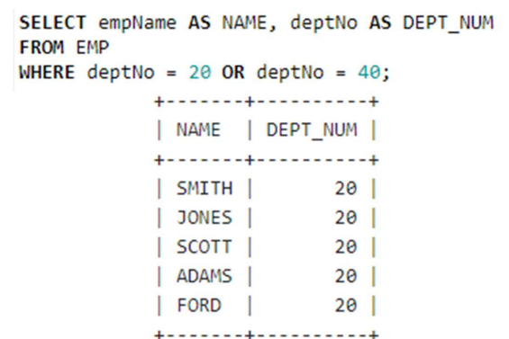

1. Find employees who are Clerk and Salesman.

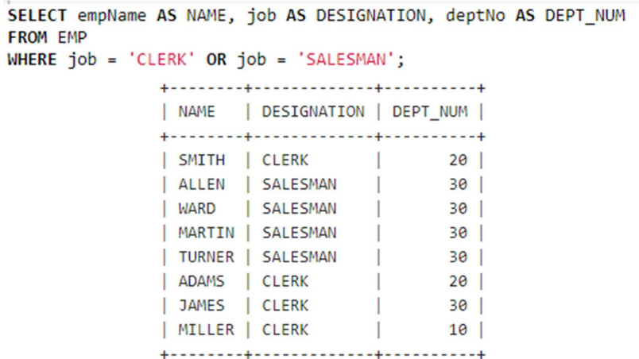

1. Find employees who are Manager and having salary more than 2000.

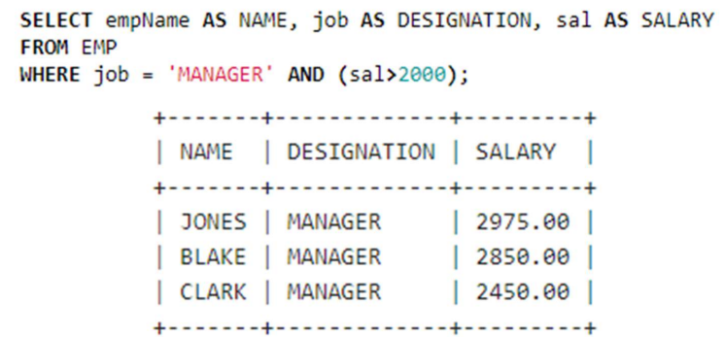

1. Find employees who are working in Department Number 30 and order them by descending order.

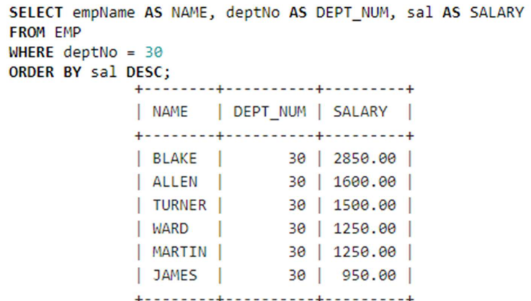

1. Find Maximum and Minimum Salary from EMP table.

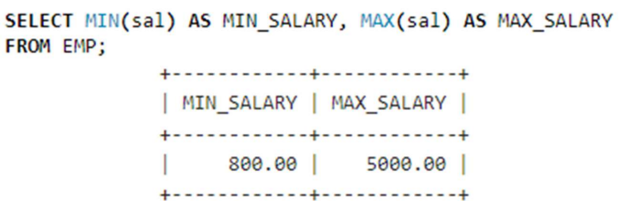

1. Display Number of Employees per Department if count is greater than 3.

